Personalized Prompting for Adaptive User-Centric Content Generation and Content Summarization using Retrieval Augmented Generation
Priyanshu Satapathy¹, Deepika Kumar^{2 *}
¹²Department of Computer Science and Engineering, Bharati Vidyapeeth’s College of Engineering, New Delhi-110063, India.
¹priyanshusat327@gmail.com, ^{2*}deepika.kumar@bharatividyapeeth.edu,
³Department of Computer Science and Engineering,

Abstract

The article introduces a personalized prompting framework on adaptive content generation with large language models (LLMs) in an easy-to-use format. Even though modern generative artificial intelligence systems might be fit to provide high-quality answers to a wide range of tasks, they are usually prompted with fixed prompts which are not aware of user expertise, preferences, context, or information needs. To mitigate this disadvantage, the proposed approach is preoccupied with personalization at prompt level whereby the prompts are adjusted dynamically with the response of the user without altering the underlying model. This is because an interactive system of the web is developed that will get queries of the user and such cues of personalization as level of expertise, the tone to be used, and the amount of detail needed. These inputs can be used to construct lightweight user profiles and, with the help of strategies, such as template-based personalization, automated prompt rewriting and few-shot prompting, one can create customized prompts. The system is also useful besides the general content generation in the case of the user specific document summarization in the sense that when the user uploads some document or gives it, the level of summarization is according to his competence or desired level of explanation. The platform includes the ability to compare generic and personalized prompts and the base language model lockdown. The evaluation used in determining relevance, clarity, usefulness, and personalization of the generated outputs is based on user feedback and basic automated analysis. The findings indicate that individual prompting and user-centered summary increases the relevancy and usability of the generated material in particular circumstances with novice users or circumstances that require making easy-to-understand explanations. Overall, this paper has demonstrated that generative AI systems can be more flexible, usable and functional at the prompt-level and remain scalable and feasible in a real-world context.

Keywords: Generative Artificial Intelligence, Large Language Models, Prompting, Personalized Prompting, Adaptive Content Generation, User Specific Document Summarization, User-Centric AI, Few-Shot Learning

1. Introduction

Nowadays, generative artificial intelligence systems have wide-ranging applications, including text generation, question answering, document summarization, and conversational assistance. Large Language Models (LLMs) have demonstrated their ability to understand and generate natural language, and they can be applied to a variety of applications. The behavior of these models is usually governed by prompt engineering, where users give the instructions or examples to follow when generating the output [1]. Techniques like zero-shot and few-shot prompting allow models to perform tasks with no models retraining, allowing for prompt-based a flexible and efficient model being interactive [2]. Recent research has further pointed to the importance of well-timed design and instruction tuning on the performance of models for the different tasks [3][4]. However, most of the prompting methods currently in use are based on static prompting in which uniform user needs and knowledge levels are assumed. In real-life situations, people who interact with artificial intelligence systems vary in their knowledge, preferences and information needs. For example, simpler explanations can be favored by a beginner, but easier and technical answers from an expert user. Static approaches to prompting often cannot adapt to such differences, forcing users to change prompts over and over again to get useful outputs from the system. Personalization has been well explored in the context of natural language processing systems, especially in the realm of recommender systems and chatbots, as preferences and past interactions with users are used to personalize output [5][6]. However, in generative AI systems, personalization is most often deployed using computationally expensive model-level methods like fine-tuning or reinforcement learning from human feedback [RLHF], with which models are optimized to general preferences of humans, but may not be able to respect individual user needs [7]. To avoid these limitations, prompt-level personalization is a possible scalable solution where prompts can be dynamically adjusted depending on user-specific signals such as expertise level, preferred tone, and level of detail. In addition to the generation of personalized content, the proposed system also enables user-specific document summarization based on Retrieval-Augmented Generation (RAG), in which relevant information on documents provided by the user is retrieved and summarized according to user requirements [8]. By combining the personalized prompting and the retrieval-based summarization, the developed system can generate more relevant and understandable and context-aware outputs, without altering the base language model. The contributions of the research are as follows:

1. To create a prompt level personalization framework for adaptive and user-centric content generation using large language models.
2. To implement user-specific document summarization by using Retrieval-Augmented Generation (RAG).
3. To compare various personalization strategies aimed to enhance the generated response for relevance and usability.
4. To develop a web-based interactive system to allow the evaluation of personalized prompting for different user requirements.

The paper follows following structure: Section 1 introduces the Section 2 explains the literature review. Section 3 shows the architecture and workflow of pipeline developed. Section 4 discusses results and analysis, accompanied by conclusion.
2. Literature Review

Recently, a massive increase has been seen in capability of machine understanding and producing natural language; this capability is known as large language models (LLMs). These models are used widely for a variety of tasks, including text generation, text summarization, question answering, conversational assistance, etc. A important technique used to control the behavior of LLMs is said to be prompt engineering, in which a user offers instructions or contextual examples to guide the model's output. Early research proved that LLMs can accomplish a range of tasks using zero-shot and few-shot prompting in which models are trained using minimal examples without any extra training [1]. Instruction tuning then further improved this functionality by allowing models to more closely follow natural language instructions in different types of tasks [2]. However, most of the prompting strategies are static and task-oriented, assuming that the needs of all users are similar and that the prompts need to be adjusted manually to receive desired outputs. At the same time, the field of personalization has been widely explored in traditional natural language processing applications such as recommendation systems and dialogue systems. These systems use user profiles, user preferences, and interaction history to enhance their relevance and user satisfaction [3]. However, such approaches are primarily aimed at selecting or ranking content as opposed to generating personalized responses. In generative AI, one way of personalization is often achieved by model-level methods such as fine-tuning or reinforcement learning from human feedback (RLHF), which enhance the alignment of the models but are computationally demanding and usually optimize for an average user rather than for individual needs [4]. To overcome such limitations, personalization at the prompt level has become a scalable alternative where the prompts are dynamically modified using user-specific information. Retrieval-Augmented Generation (RAG) further improves this process by also retrieving relevant information from external documents and incorporating them in the prompt to provide more accurate information from a factual and contextual aspect [5]. In addition, automated prompt optimization and meta-prompting methods indicate that LLMs can automatically generate or optimize prompts in order to better a task [6]. Although these are foundational issues of individualization, there has, so far, been little research on the systematic personalization of prompts using explicit user signals. Another challenge that has been brought up in recent studies is the issue of reliability and safety of generative AI systems. Contextual prompts are sometimes leading to hallucinations or injecting unwanted bias especially when models try to infer missing information [4][5]. In addition, many research studies for language models review models by automatic metrics, with little focus on human-metric observations - for example, relevance, usability, and personalization metric evaluations. These gaps suggest that there is also need for research that interrogates adaptive prompting strategies that are able to increase the level of personalization without compromising the level of reliability and fairness. Overall, the current literature shows the potential of prompt engineering, retrieval-augmented techniques and automated prompt optimization in enhancing the performance of language models. However, there remains a need for frameworks that one that combine these techniques with user-centric personalization. This research tackles these issues by focusing on strategies that can be used for prompt-level personalization and combining user-specific document summarization abilities using retrieval-augmented generation to better the relevance and usability of generated content.

Table 1: Literature Review

Source | Title | Author | Year | Methodology | Limitations | Results/Metrics
[1] | Evaluation and  Development of Innovative NLP Techniques for  Query-Focused  Summarization  Using RAG and  SLM | Kirillos Akram  Sawiras | 2024 | Developed QFS system using  RAG, BM25, dense retrieval,  prompt engineering, and SLM/LLM  models for educational  summarization. | Focused on educational  domain; limited  multimodal support;  requires predefined  corpus. | ROUGE-L ≈  0.48, BLEU ≈  0.42;  improved  summary  relevance  with reduced  token cost
[2] | Multi Model  RAG  Application: AI  Observability &  Document  Intelligence | Prof. Disha  Nagpure,  Aditya  Suryawanshi,  Shardul  Deshmukh,  Sujal Pore | 2025 | Developed multimodal RAG  chatbot platforms (SASAi and  Studently.ai) integrating vector  databases, CrewAI agents, and  observability tools. | Requires complex  infrastructure; limited  public benchmarking;  heavy deployment  requirements. | QA Accuracy  ≈ 85–87%,  F1 (Parsing)  ≈ 0.84,  Latency ≈  3.2–3.6 s
[3] | Towards a  Robust  Retrieval-  Based  Summarization  System | Shengjie Liu,  Jing Wu,  Jingyuan  Bao, Wenyi  Wang, Naira  Hovakimyan,  Christopher  G. Healey | 2024 | Proposed LogicSumm evaluation  pipeline and SummRAG  framework to enhance robustness  of RAG-based summarization  across noisy scenarios. | Focuses on robustness  evaluation rather than  personalization;  performance depends on  retriever accuracy. | Significant  improvemen  t in logical  accuracy;  evaluated  using  ROUGE-1/2  /L and  BERTScore
[4] | From Local to  Global: A  GraphRAG  Approach to  Query-Focused  Summarization | Darren Edge, Ha  Trinh, Newman  Cheng, Joshua  Bradley, Alex  Chao, Apurva  Mody, Steven  Truitt, Dasha  Metropolitansky,  Robert Osazuwa  Ness, Jonathan  Larson | 2025 | Introduced GraphRAG,  constructing knowledge  graphs and community  summaries to answer  corpus-level questions  and enable global  sense-making. | Computationally  intensive graph  construction;  complex  deployment; limited  real-time  performance. | Higher  comprehensiveness  & diversity vs vector  RAG on large  corpora
[5] | Retrieval-Augmented Generation  For Knowledge-Intensive NLP Tasks | Patrick Lewis,  Ethan Perez,  Aleksandra Piktus,  Fabio Petroni,  Vladimir  Karpukhin, Naman  Goyal, Heinrich  Küttler, Mike  Lewis, Wen-tau  Yih, Tim  Rocktäschel,  Sebastian Riedel,  Douwe Kiela | 2020 | Introduced RAG  combining neural retrieval  with sequence generation  to ground outputs in  external knowledge  sources. | Limited  personalization;  struggles with  long-context  reasoning without  advanced indexing. | Open-domain QA  EM ≈ 44.5%, F1 ≈  56.1% (Natural  Questions dataset)
[6] | BERT:  Pre-training of  Deep  Bidirectional  Transformers for  Language  Understanding | Jacob Devlin,  Ming-Wei  Chang, Kenton  Lee, Kristina  Toutanova | 2019 | Proposed  transformer-based  contextual embeddings  enabling major advances  in NLP tasks | Not generative;  requires fine-tuning;  no retrieval  component. | GLUE score ≈ 80.5;  SQuAD v1.1 F1 ≈  93.2
[7] | LangChain:  Building  Applications  with LLMs  Through  Composability | Harrison  Chase  (LangChain  Contributors) | 2023 | Provides  framework for  building  modular  pipelines  integrating  prompting,  retrieval, tools,  and agents. | Adds orchestration  overhead;  performance depends  on external models  and data quality. | End-to-end QA  accuracy up to ≈  80–90% in document  QA tasks  (system-dependent);  Latency typically ≈ 2–8  s per query; Enables  scalable multi-step  reasoning workflows
[8] | PEGASUS:  Pre-training  For Abstractive  Text  Summarization | Jingqing  Zhang,  Yao Zhao,  Mohamma  d Saleh,  Peter Liu | 2020 | Designed a  pre-training  objective  tailored for  abstractive  summarization  using  gap-sentence  generation. | Limited to text;  cannot incorporate  external knowledge  dynamically. | ROUGE-1 ≈ 44.2,  ROUGE-2 ≈ 21.6,  ROUGE-L ≈ 41.3  (CNN/DailyMail)

Similarly, the findings of current research works on the applications of large language models and prompt engineering are discussed, including the great progress made by generative AI systems for tasks like text generation, summarization, and conversational assistance. Techniques such as prompting, instruction tweaking and retrieval augmented generation have enhanced the ability of models to generate relevant and context-aware outputs. However, most approaches that do exist are task oriented, and do not adequately account for diversity of user needs and preferences. Model-level personalization techniques, despite their high success rate of better alignment, are often computationally expensive and are hard to scale for practical application. Moreover, existing systems often do not take a user-centric view on personalization, nor do they consider the performance of different prompting strategies for diverse groups of users. Motivated by these gaps, the current study focuses on the development of prompt level personalization framework that includes user specific signals and retrieval augmented document summarization in an effort to increase the horsepower of document summative generation in terms of relevance, usability, adaptability, while still maintaining efficiency and scalability.

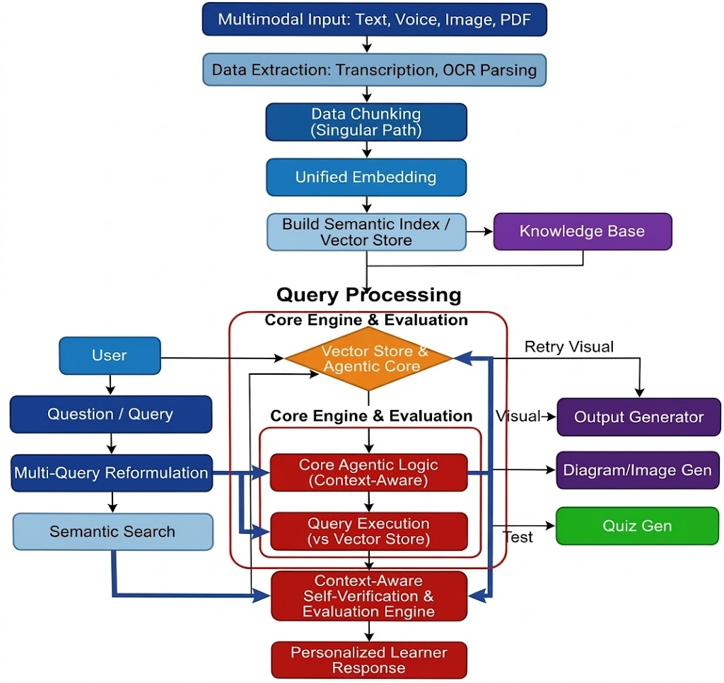

Figure 1: Personalized Prompting and Content Generation System

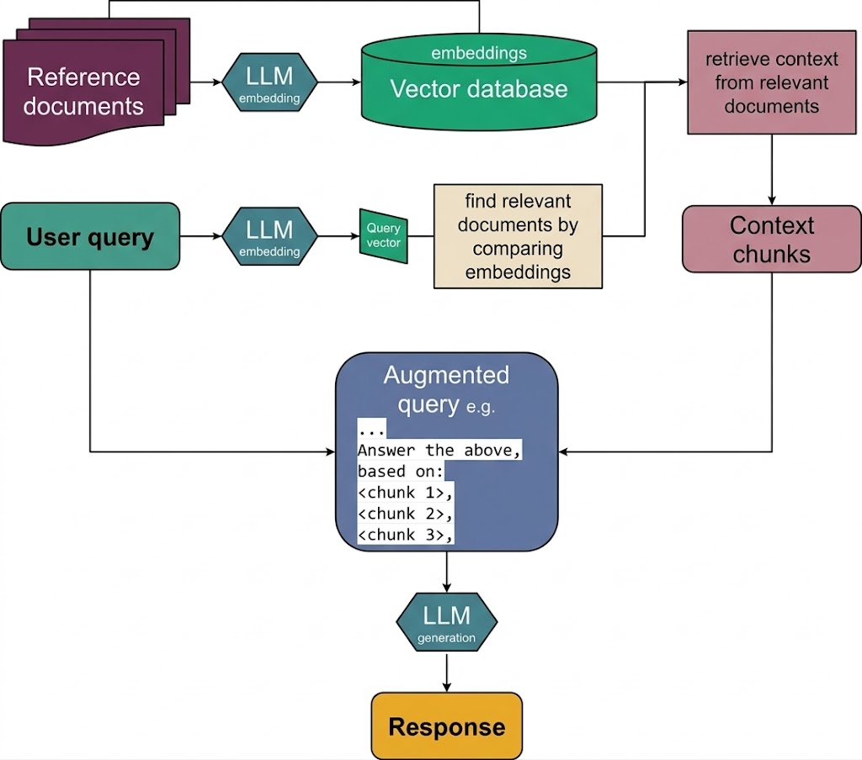

Figure 2: Content Summarization and Document Summarization using Retrieval Augmented Generation

3. Proposed Methodology

The proposed system is aimed at providing personalized document content generation and document summarization via Retrieval-Augmented Generation (RAG). The framework combines the use of multimodal inputs processing, intelligent routing of queries, context-aware generating responses and evaluation mechanisms for reliable and user-centric outputs. The system supports various input formats like text, voice, images and documents and converts them to the unified textual format for further processing. Retrieved contextual knowledge from document sources is combined with large language models in order to generate accurate and personalized responses The proposed workflow of the overall framework is shown in Figure 1.

3.1 Multimodal Query Processing and Adaptive Response Generation

The first component of the framework focuses on processing user queries provided in different modalities and generating adaptive responses based on retrieved contextual information.

3.1.1 Multimodal Input Processing

The system supports multiple formats of input like text, voice, images, document-based queries etc. Voice inputs are translated to text-form with the Whisper speech to text model, which results in perfectly transcribed answers to spoken queries. Text Inputs are processed with EasyOCR that can be used to extract textual content from images. For document-based inputs like PDF, DOCX, text extraction is done using libraries such as PyMuPDF, python-docx. After conversion, all inputs are converted to a consistent textual format in order to facilitate consistent posterior processing through the language model.

3.1.2 Hybrid Multi-Query Retrieval

In order to have an acceptable contextual interpretation, a hybrid retrieval mechanism is adopted. Sentence-Transformer embeddings (MiniLM) are used in the system to transform queries into vectors. Such embeddings are stored in a FAISS vectors database, where similarity can be easily found. Besides, semantic retrieval, there are also also the relevance of lexical relevance searching methods, like the for example BM25-style matching. In addition, the query is reworded with the help of an LLM-based query expansion model to produce numerous variations of the user query. The hybrid method of retrieval enhances the capacity of the system to find the most contextual information.

3.1.3 Agentic Task Routing

When the query context has been retrieved, the system identifies the intent to decide on the task to do. This is done by employing a classification module based on LLCM coupled with rule logic. In accordance with the intent identified, the query is sent to special tools. The questions to the question-answering module are those that require facts, the diagram creation with the help of Graphviz is considered to be the visualization query, the image generation tools handle image query, and the quiz or educational modules can be used to process the queries related to the learning. Such agentic routing process helps the system to choose the most appropriate tool in the dynamic selection of a task.

3.1.4 Context-Aware Adaptive Response Generation

The responses are created by the system after retrieval and routing a transformer-based large language model, such as LLaMA or GPT embedded a RAG pipeline. The user query is inputted to the model along with the contextual information that has been retrieved and incorporated into the model. The model will then generate responses that are anchored on the information that has been recalled and changes the explanations as per the level or preference of learning chosen by the user. This makes sure that the answers are relevant, personal and context sensitive.

3.1.5 Self-Verification and Evaluation

The responses generated are subjected to a self-verification stage in order to enhance reliability. The output is against the backdrop of compared contextual information to ascertain the facts. A number of assessment measures are used, such as grounded accuracy to describe the faithfulness to source information, scores to evaluate the reduction of hallucinations to identify the misadded or falsified content, BLEU/ROUGE-style similarity measures to assess the alignment between the text, and the overall confidence score. These steps of evaluation are taken because the responses that have been generated are ensured to be highly reliable and contextually correct.

3.1.6 Evaluation Metrics for Multimodal Query Processing and Adaptive Response Generation

In order to measure the performance and reliability of the produced responses, a few evaluation metrics are applied such as grounded accuracy, hallucination reduction score, BLEU/ROUGE similarity, response accuracy and confidence score.

Response Accuracy

Accuracy = N_{correct /} N_{total} (i)

where
$N_{correct}$= Total number of correct responses
$N_{total}$= Total number of evaluated responses.

Grounded Accuracy (Faithfulness)

Grounded Accuracy = |R∩C|/ |R| (ii)

where
$R$=set of information units in generated response
$C$= set of information units present in retrieved context.

Hallucination Rate

Hallucination Rate = |R – C|/ |R| (iii)

Hallucination Reduction Score

Hallucination Reduction = 1 – Hallucination Rate (iv)

where
$R-C$ represents unsupported information generated by the model.

BLEU Score

BLEU = BP * exp(sum{n=1 to N} (w_n * log(p_n))) (v)

where
$BP$=brevity penalty
$p_{n}$=precision of n-grams
$w_{n}$= weight assigned to each n-gram

Confidence Score

Confidence = max P(y | x) (vi)

where
$P(y∣x)$represents the probability of generating response $y$ given input $x$.

3.2 Document Summarization using Retrieval-Augmented Generation (RAG)

The second element of the framework is the context preserving document summarization, whereby users are allowed to upload documents and create summaries without having to lose the original context.

3.2.1 Document Input and Preprocessing

Users upload textual documents through the system interface in formats such as PDF, DOCX, or plain text. The system extracts textual content and performs preprocessing steps including text cleaning, normalization, and removal of unnecessary symbols. Long documents are divided into smaller segments or chunks to facilitate efficient processing and retrieval.

3.2.2 Document Embedding Generation

A sentence embedding model gets each chunk of document converted to the vector embeddings. These embeddings embody the semantic meaning of every piece of document. It stores the generated embeddings in a vector database allowing similarity-based efficient retrieval of the different relevant parts of the documents.

3.2.3 Context Retrieval Mechanism

When the user switches to document context mode, the system will retrieve the necessary chunks in the uploaded document. The similarity search between query to user and stored embeddings is used to retrieve the item. The most relevant segments are taken as the top-k to be used as a representation of the contextual knowledge to be summarized.

3.2.4 Prompt Construction with Retrieved Context

The document fragments that are retrieved are put together with an organized summary prompt. This command advises the language model to come up with summaries depending solely on the context of the given document. Other preferences of the user like the length of the summary or the level of explanation can be implemented at this point as well.

3.2.5 Context-Aware Summarization

The created prompt with the context retrieved is fed into the large language model implemented in the RAG framework. The model will produce a summary of a document that will contain important information without losing the original meaning and context of the document. The system has an ability to minimize hallucination and enhance factual accuracy by basing the generation process on retrieved document fragments.

3.2.6 Output Generation and User Interaction

The system interface provides the user with the generated summary. The user is able to regenerate summaries, change the length of summary, or change the parameters on personalization. When the context mode is turned on the system will make sure that the summaries are in line with the document being uploaded.

3.2.7 Evaluation Metrics

Document summarization quality is measured with the help of standard summarization measures such as ROUGE scores, semantic similarity and context preservation measures.

ROUGE-1 Score

ROUGE-1 is used to analyze overlap of unigrams between generated summary and reference summary.

ROUGE-1 =(sum{w in Ref} min(count_gen(w), count_ref(w))) / (sum{w in Ref} count_ref(w)) (i)
where
$count_{gen}(w)$= occurrences of word $w$in generated summary
$count_{ref}(w)$= occurrences of word $w$in reference summary.

ROUGE-L Score
ROUGE-L measures similarity with longest common sequencing between the generated and the reference summary.

ROUGE-L = LCS(Gen, Ref) / length(Ref)

where
$LCS$= longest common subsequence between generated summary and reference summary.

Semantic Similarity Score

Semantic similarity is the degree to which the generated summary is similar to the original document by measuring the degree of similarity using the cosine similarity.

Similarity = (A · B) / (|A| × |B|)

where
$A$= embedding vector of generated summary
$B$= embedding vector of reference text.

3.2.9.4 Context Preservation Score

This measure is used to determine the extent to which the summary generated by the system is verified by the retrieved document context.

Context Preservation = |S ∩ D| / |S|

where
$S$= information units in generated summary
$D$= information units in retrieved document context.

3.2.9.5 Context Preservation Score

Compression ratio shows how much condensation was reached in the process of summarization.

Compression Ratio = Length_summary / Length_document

A lower compression ratio indicates stronger summarization.

4. Results and Analysis

